|  |  |
| --- | --- |
|  |  |

**Faculty of Technology and Engineering**

**Chandubhai S. Patel Institute of Technology (CSPIT)**

**Department of Computer Science & Engineering**

Date: / /

**Laboratory Manual**

|  |  |  |  |  |  |
| --- | --- | --- | --- | --- | --- |
| Academic Year | : | 2024-25 | Semester | : | 4 |
| Course code | : | CSE206 | Course name | : | DATABASE MANAGEMENT SYSTEM |

|  |
| --- |
| **Practical - 2** |
| **Aim: Global Trust Bank is expanding its operations and requires a robust database management system to efficiently manage its employees, job profiles, customers' accounts, and loan information. The bank has laid out specific requirements and constraints to ensure data integrity, uniqueness, and completeness. Perform Data Definition Language (DDL) commands and change the existing schema as per the given information.**  **Constraints –**   * Not Null Constraints: Ensure critical fields are not null. * Unique Constraints: Ensure data integrity by limiting column values. * Check Constraints: Ensure columns like Account Number have unique values. |

**Tasks:-**

1. Create a table supplier from an employee with all the columns and verify.

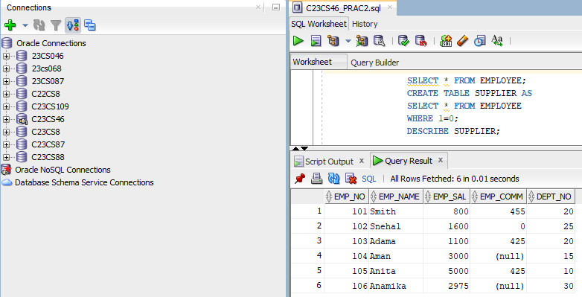

1. Create table sup1 from an employee with the first two columns and verify.

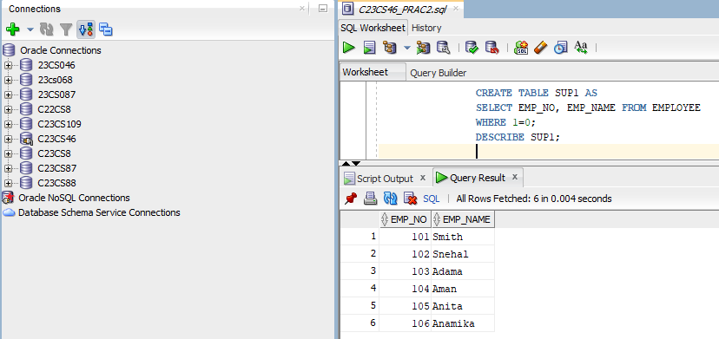

1. Create table sup2 from employee with no data and verify.

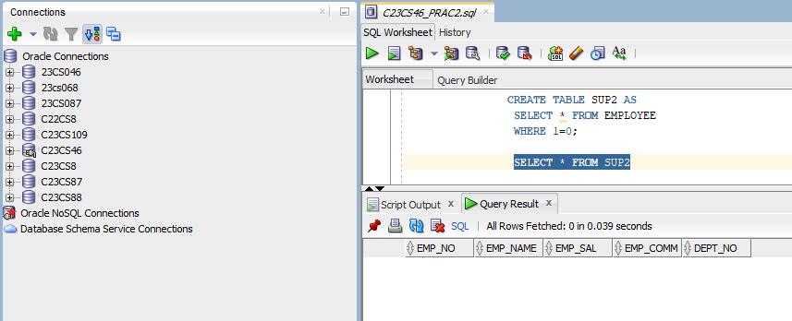

1. Insert the data into sup2 from employee whose name is ‘Anita’ and verify.

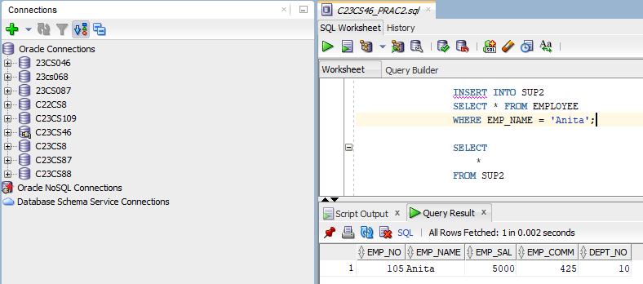

1. Rename the table sup2 and verify.

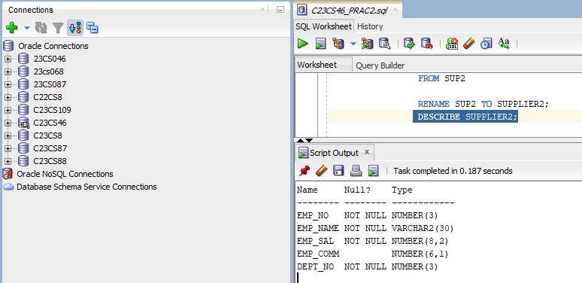

1. Destroy table sup1 with all the data and verify.

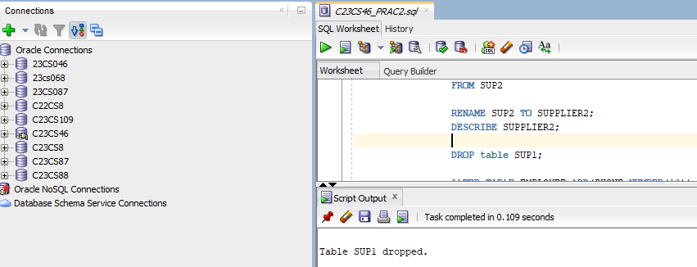

1. Add one column phone to an employee with size of column is Varchar2(10) and verify.

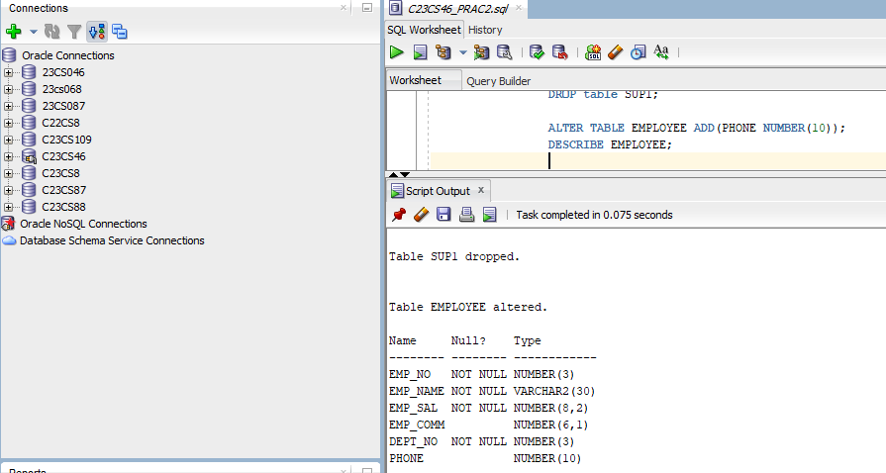

1. Modify column phone and change type to char(10) and verify.

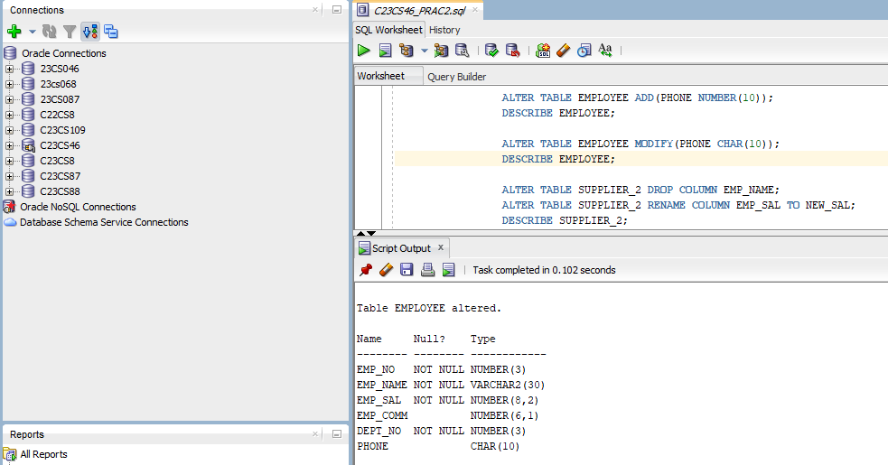

1. Delete employee_name column from sup2 and verify;

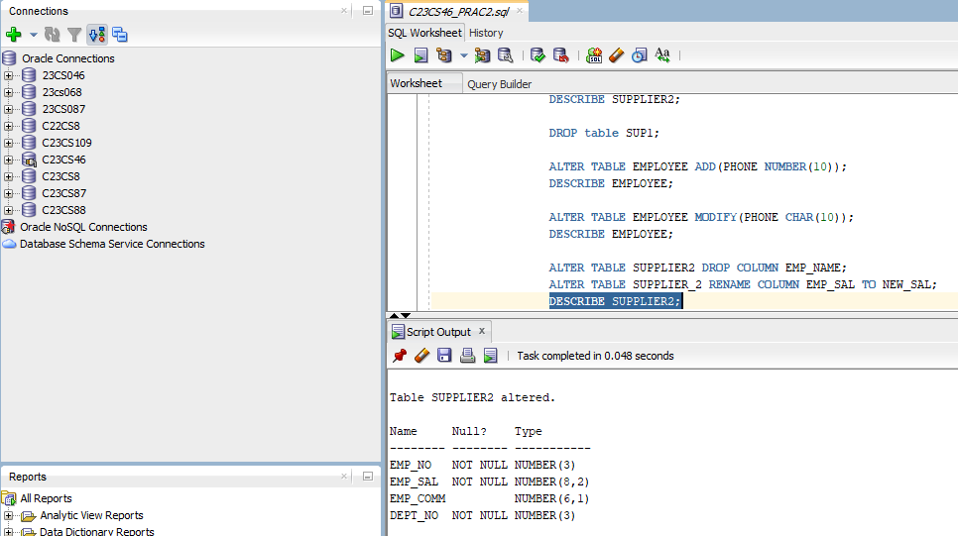

1. Rename the column salary to new_sal in sup2 and verify.

